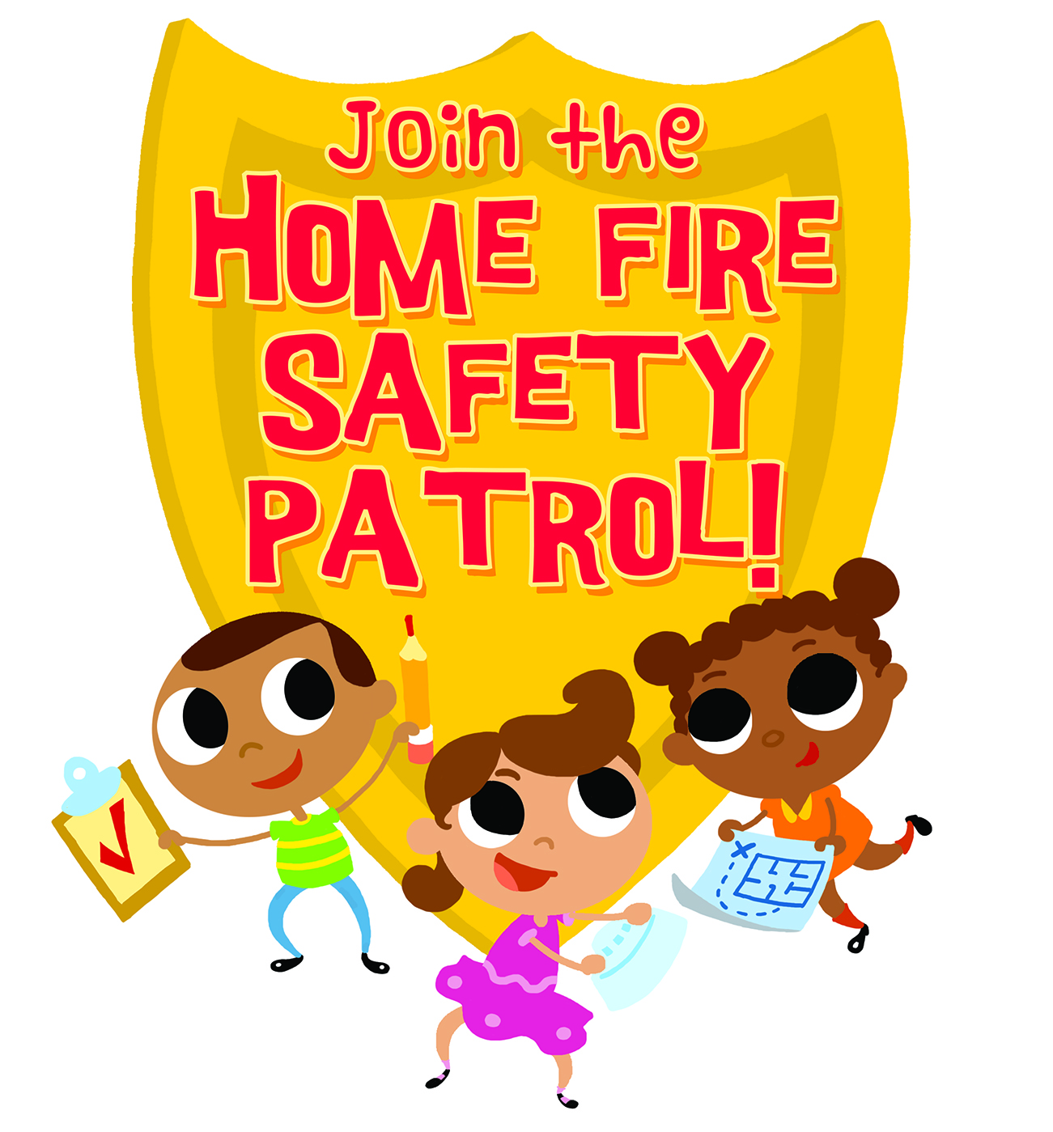

Will you and your family be able to survive a fire in your home?
Your chances will be a lot better if you have working smoke alarms!

[Insert Date]

Dear Families:

Your child is part of an exciting fire safety program at school. Students will learn about smoke alarms and how to stay safe from a fire at home. As homework, they will ask you to help them count and push the test button on all the smoke alarms in your home. The students will report on how many alarms they have and how many are working.

Only working smoke alarms can protect the ones you love. The [insert ______ Fire Department and Injury Free Kids Coalition] want to make sure you have at least one alarm on every floor and alarms in your bedrooms to protect you while you sleep. We also want to help you prevent fires from starting in your home and to know what to do if your alarms go off.

We would like to visit your home to make it safer from fire. We can help you test your alarms and install new smoke alarms for free if you need some.

To make an appointment, please fill in your name and phone number. We will call you to set up a time for our safety team to visit your home.

Thank you for being part of the Home Fire Safety Patrol! Together, we can make sure that your family stays safe.

Sincerely,

[partner organizations]

Student Name _________________________________
Parent/Caregiver Name __________________________
Phone Number _________________________________

[Insert your logos here]

