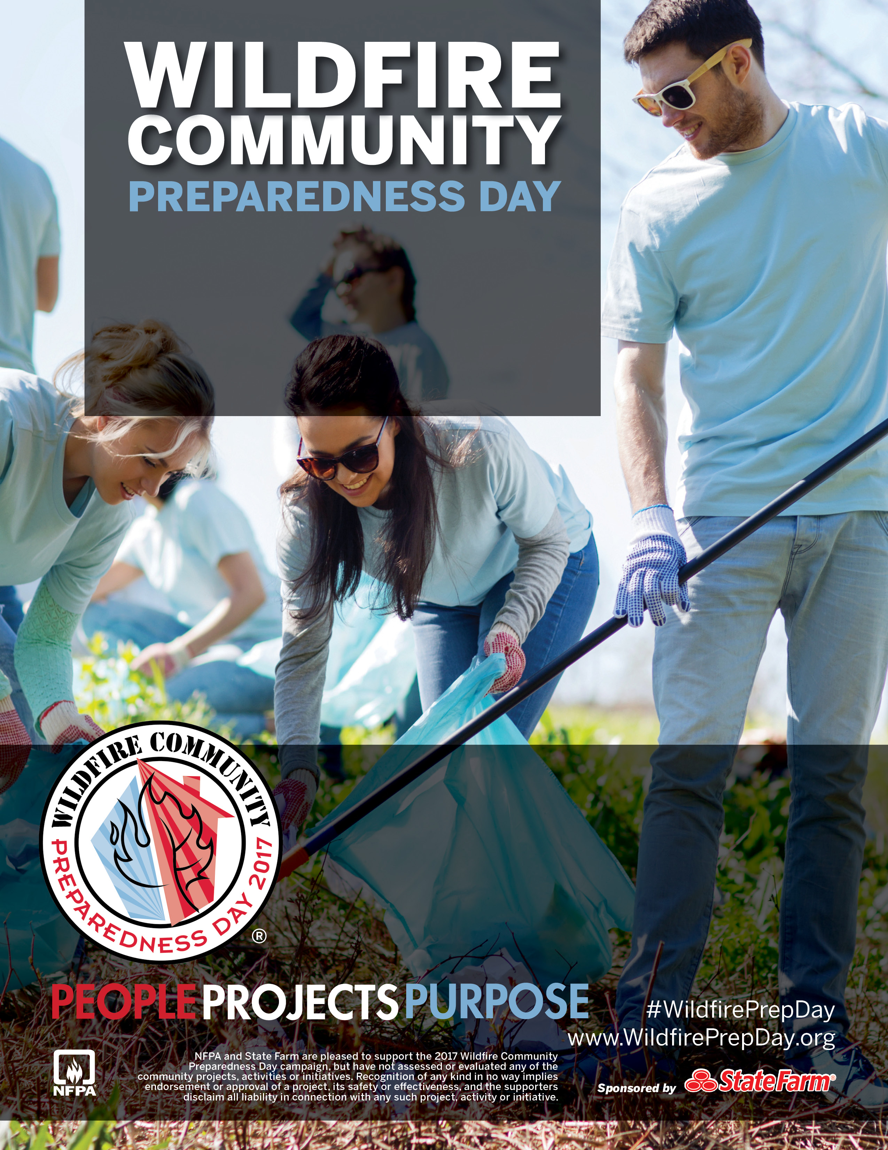

*Sample Personalization:* Join the Ponderosa Pine Community Group as we create a fire resistant plant species demon

**Where:** Chinook Elementary School

**When:** Saturday, May 7 from 9am to 2 pm

**Details**: Bring garden gloves, a shovel and wear long pants and closed toed shoes

Ponderosa Community Group will provide bottled water, snacks and a sack lunch to all participants

stration garden.

Customize this flyer to promote your local project! Enter your personalized details in the text box here.

**Email Joan at** [**joan@chinook.edu**](mailto:joan@chinook.edu) **by May 4**

Saturday, May 6, 2017