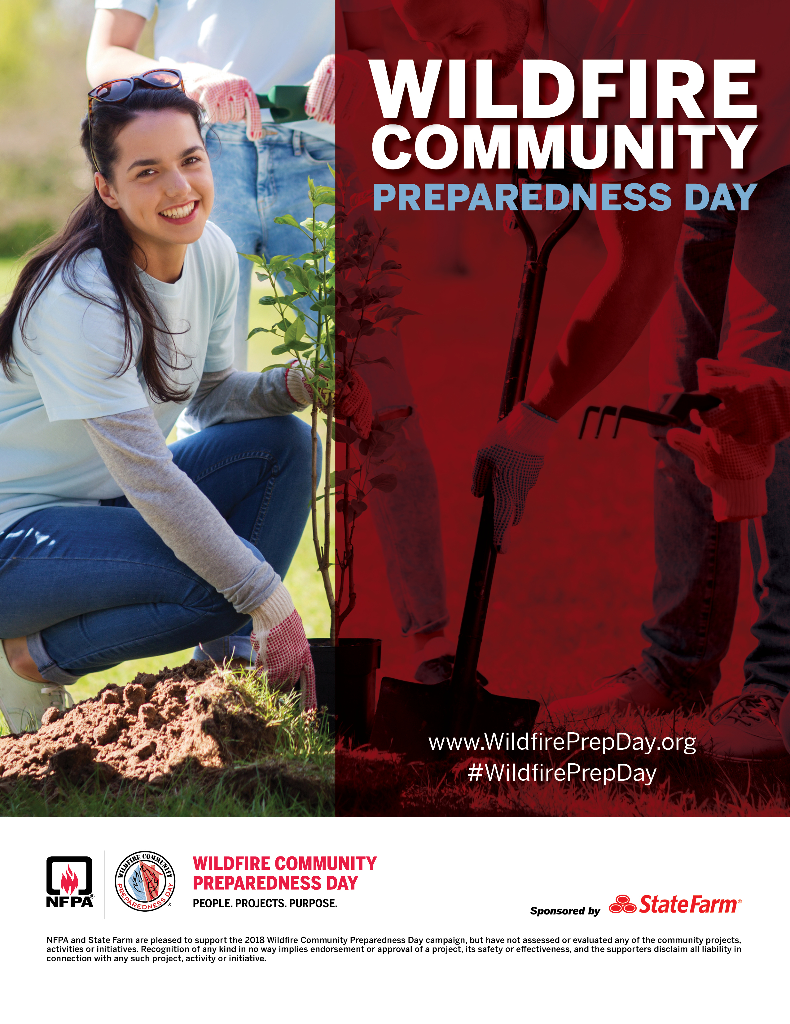

Customize this flyer to promote your local project!

Enter your personalized details in the text box here.

*Sample Personalization:* Join the Ponderosa Pine Community Group as we create a fire resistant plant species demon

**Where:** Chinook Elementary School

**When:** Saturday, May 5 from 9am to 2 pm

**Details**: Bring garden gloves, a shovel and wear long pants and closed toed shoes

Ponderosa Community Group will provide bottled water, snacks and a sack lunch to all participantsstration garden.

Saturday, May 5, 2018