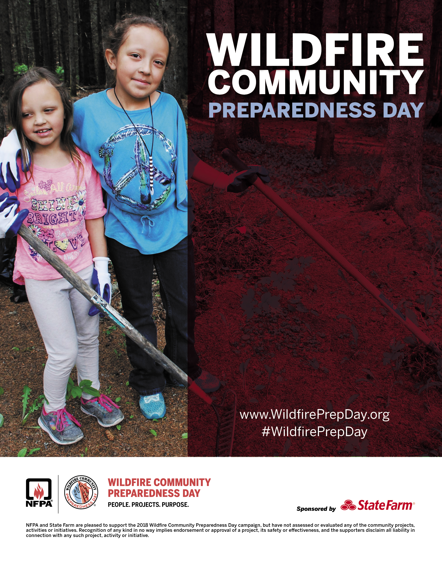

Customize this flyer to promote your local project!

Enter your personalized details in the text box here.

*Sample Personalization:* Join the Ponderosa Pine Community Group as we create a wildfire safety garden.

**Where:** Chinook Elementary School

**When:** Saturday, May 7 from 9 am to 2 pm

**Details**: Bring garden gloves, a shovel, and wear long pants and closed-toe shoes

Ponderosa Community Group will provide bottled water, snacks, and a sack lunch to all participants.

Saturday, May 4, 2019